# 1. Introduction

This project is about a web app that facilitates a group of users to run a chit fund. The list of features which are MVP (minimum viable product) for this are

1. User to login
2. On login see the list of chits
3. Ability to add a new chit
4. For each chit see the details of the chit
5. Ability to add new members to the chit

A Chit fund is a savings scheme practiced a lot in Southern India. A chit fund company is a company that manages, conducts, or supervises such a chit fund. Goals of the project is to create an application that would be allow a foreman to run and track the chit, and subscribers to track their payments and the bid money.

This application would allow any pool of trusted individuals to start a local chit fund and

operate. This is how this whole scheme has rooted by Indian house wives and has

become popular.

# 2. Design and Implementation

## 2.1 The Rest API Specification

### 2.1.1 /login

URL = /login

HTTP Verbs = POST

Passport module with local authentication will be used. HTML form with username and password would be used to post.

### 2.1.2 /chits

URL = /chits

HTTP Verbs = GET, POST

GET Returns the list of chits in JSON format.

[

{

chitname: String,

startdate: String,

months: Number

}

]

POST adds a chit to the list

Body of the POST is

{

chitname: String,

startdate: String,

months: Number

}

### 2.1.3 /chits/{id}

URL = /chits/{id}

HTTP Verbs = GET, PUT

GET returns

{

chitvalue: Number,

[

month: String,

bidamount: Number,

bidder: String,

[

{name: String, paid: Boolean }

] // members

] // months

}

### 2.1.4 /chits/id/member

URL = /chits/{id}/member

HTT Verbs = POST

POST body is

{

name: String

}

## 2.2 Front-end Architecture Design

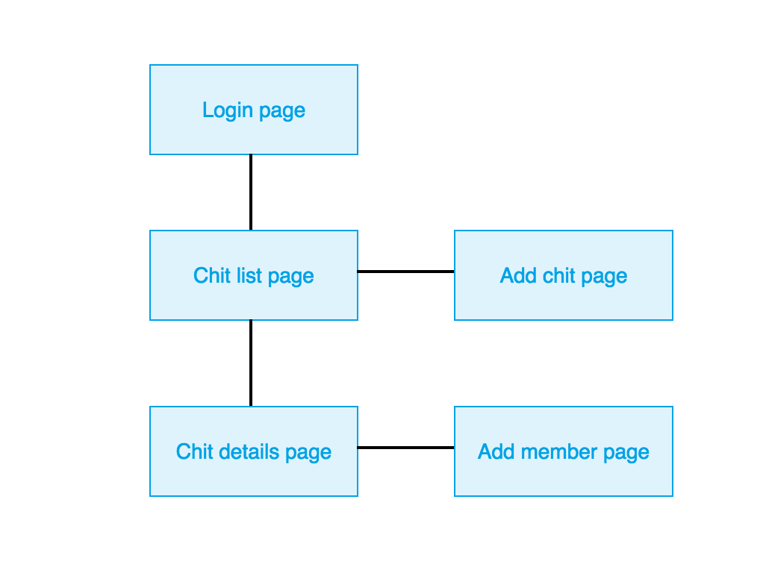

Navigation structure above shows the flow of control from one page to another

1. Login page takes to Chit list page on successful login.
2. Chit list page
   1. Takes back to login on user action “log out”
   2. Takes to Add chit page on clicking “Add new chit” button
   3. Takes to “Chit details page” on clicking hyper link of any chit from the list
3. Add Chit page allows to add the chit to the list and after adding takes back to “Chit list page”.
4. Chit details page
   1. Takes back to login on user action “log out”
   2. Takes to Add member page on clicking “Add new member” button
   3. Takes back to Chit list page on clicking “submit” or selecting bread crumb “Chit list”
5. Add member page allows to add a new member to the chit and after adding takes back to “Chit details page”.

Front end would be in Angular JS, using MVC model.

## 2.3 Database Schemas, Design and Structure

### 2.3.1 User

User schema will be

{

username: String,

password: String,

}

All users are admins, non admins are not allowed to login and view the information. As the app is only used for administrators this is good enough. In next phase this could be extended to non admin users to look at their individual data

### 2.3.2 Chit

Chit Schema will be

{

chitvalue: Number,

months: Number,

[

month: String,

bidamount: Number,

bidder: String,

[

{name: String, paid: Boolean }

] // members

] // months

}

In next phase we can add Schema for User and add the ability to add, track users and link users to chits.

Database would be mongoose database with documents.

## 2.4 Communication

The structure of the message communication is JSON only.

### 2.4.1 Struct of list of chits in JSON format

[

{

chitname: String,

startdate: String,

months: Number

}

]

### 2.4.2 Structure of chit in JSON format while adding

{

chitname: String,

startdate: String,

months: Number

}

### 2.4.3 Structure of chit returned is

{

chitvalue: Number,

[

month: String,

bidamount: Number,

bidder: String,

[

{name: String, paid: Boolean }

] // members

] // months

}

### 2.4.4 Structure of chit while adding

{

name: String

}

# 3. Conclusions

Summary: Front end application will be an Angular application communicating using REST API with backend. Backend will be an express node.js application using mongoose database to persist the data.

Below I have the UI prototype. Prototype consists of five pages. The first page is a **login page**. This is the master page and once the user logs in, the application displays the page **Chit lists page**. Chit lists page provides the organizer of chit fund a view of the list of chits and details of the chit. Each entry in the list is a hyper link that takes you to Chit details page that displays the chit details. There is also a button at the bottom of the Chit lists page that allows you to add a new chit.

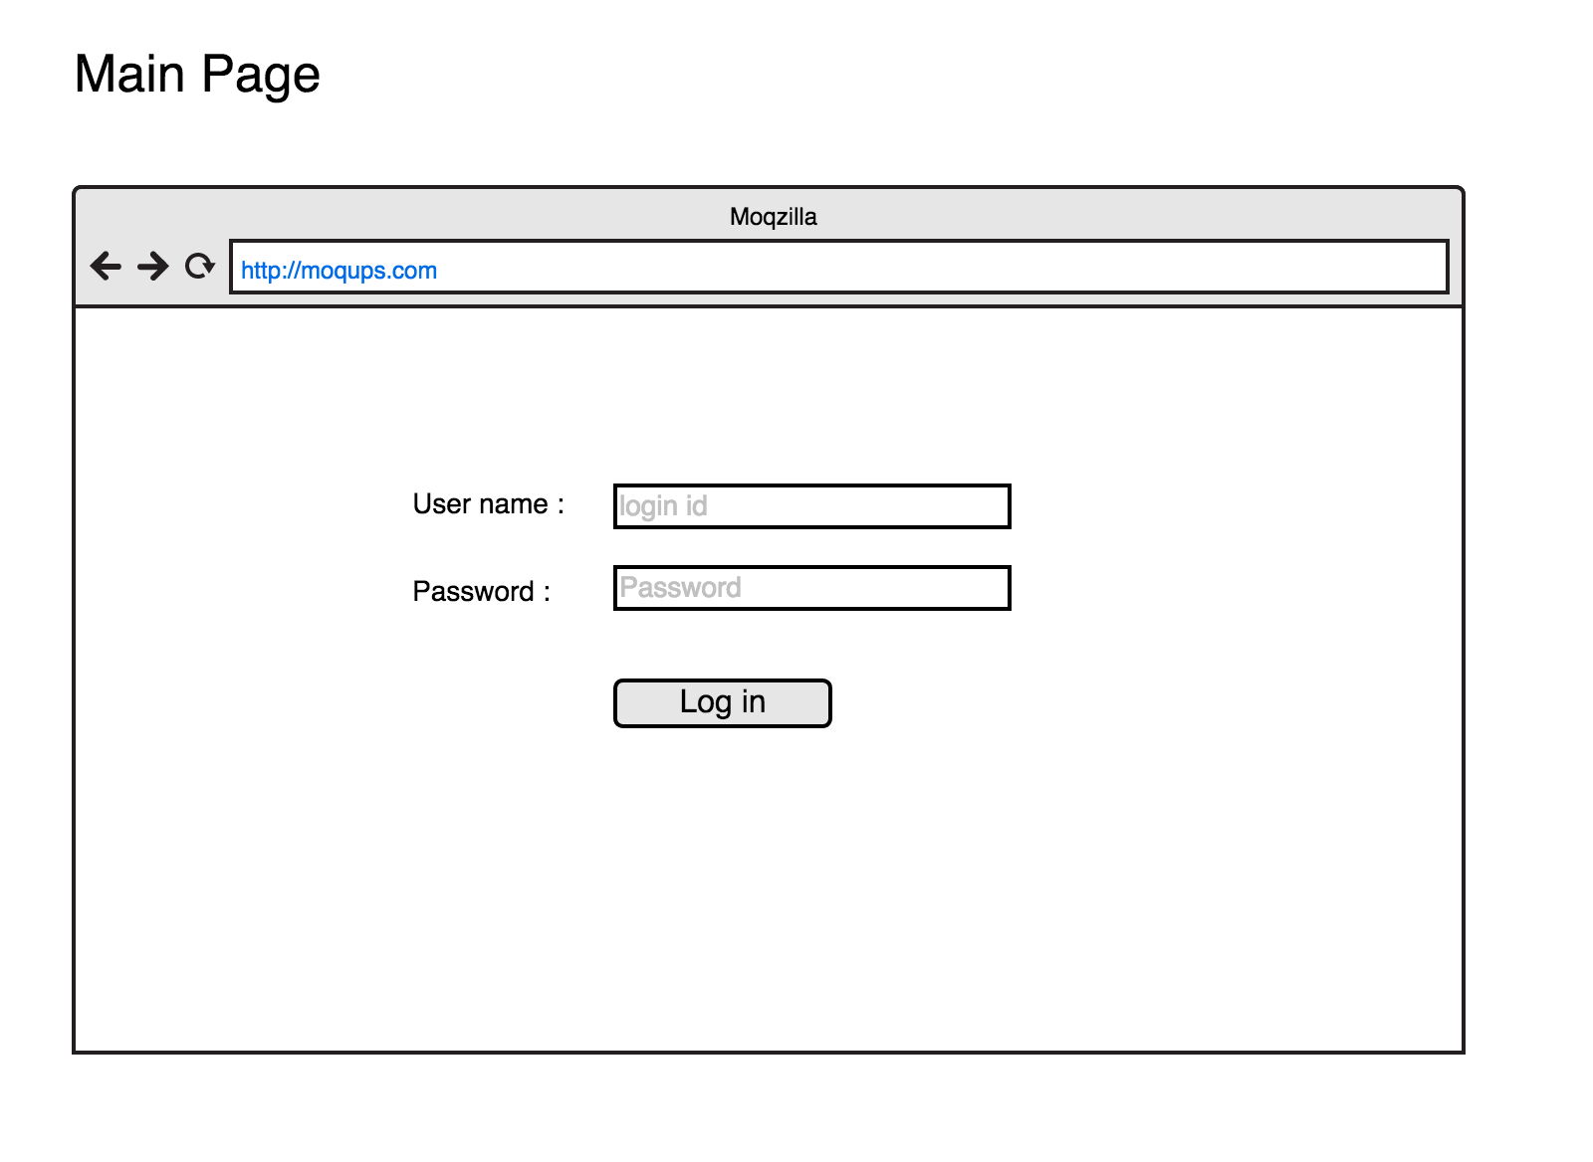

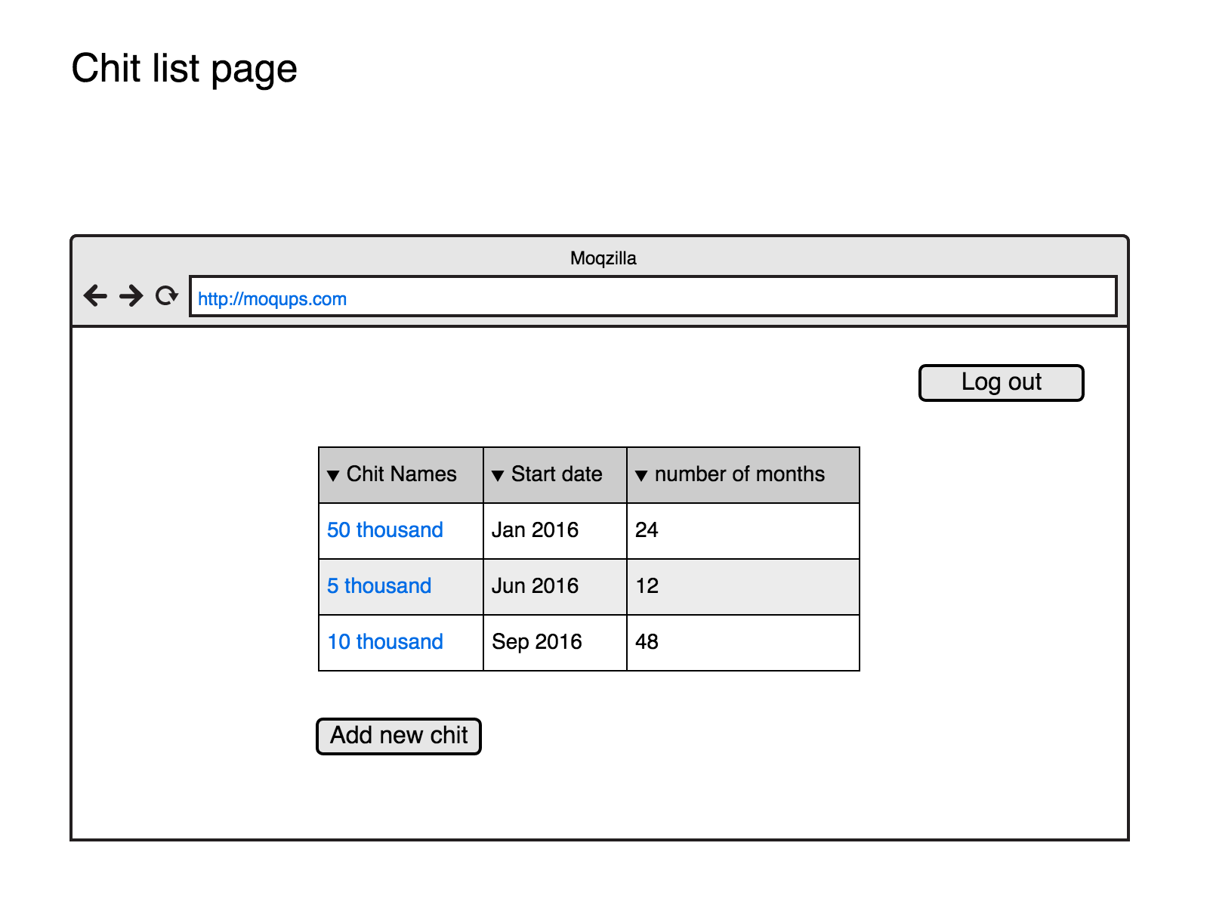

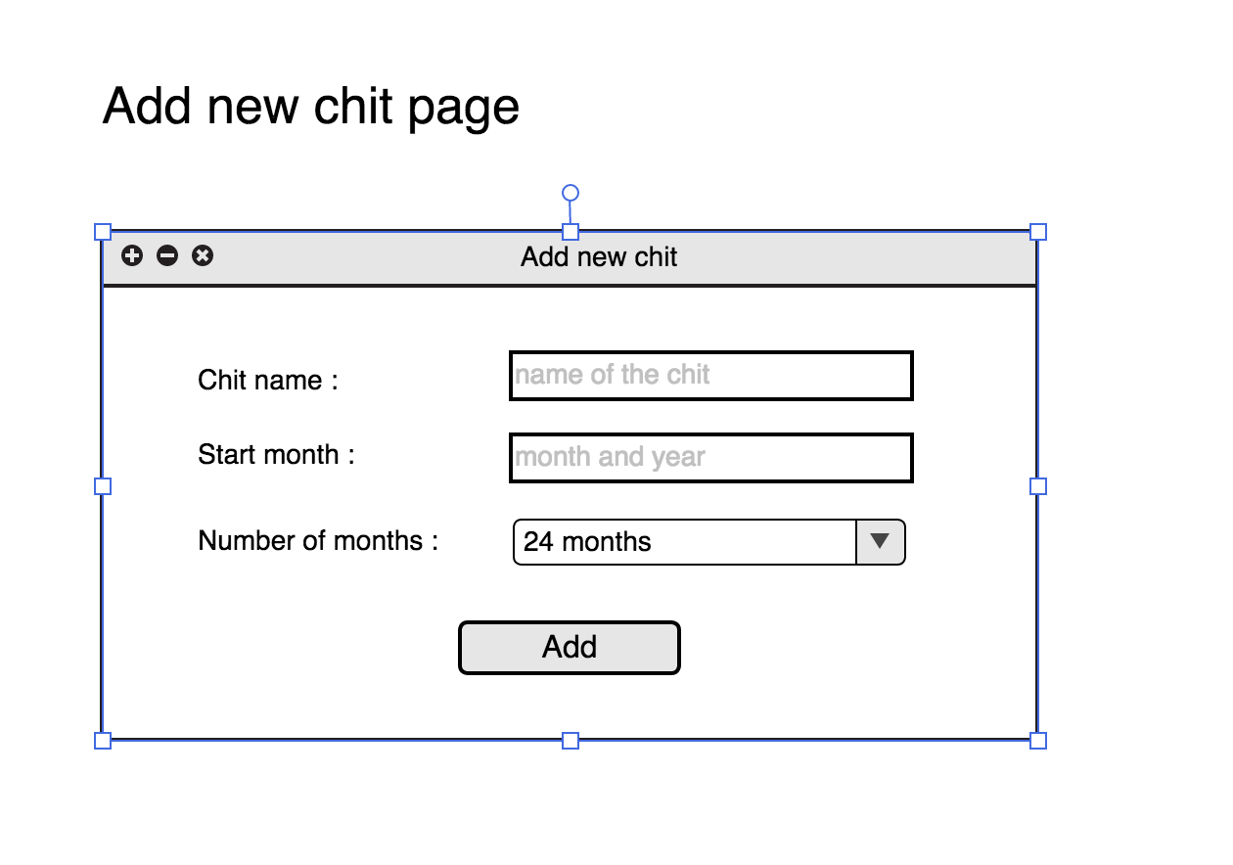

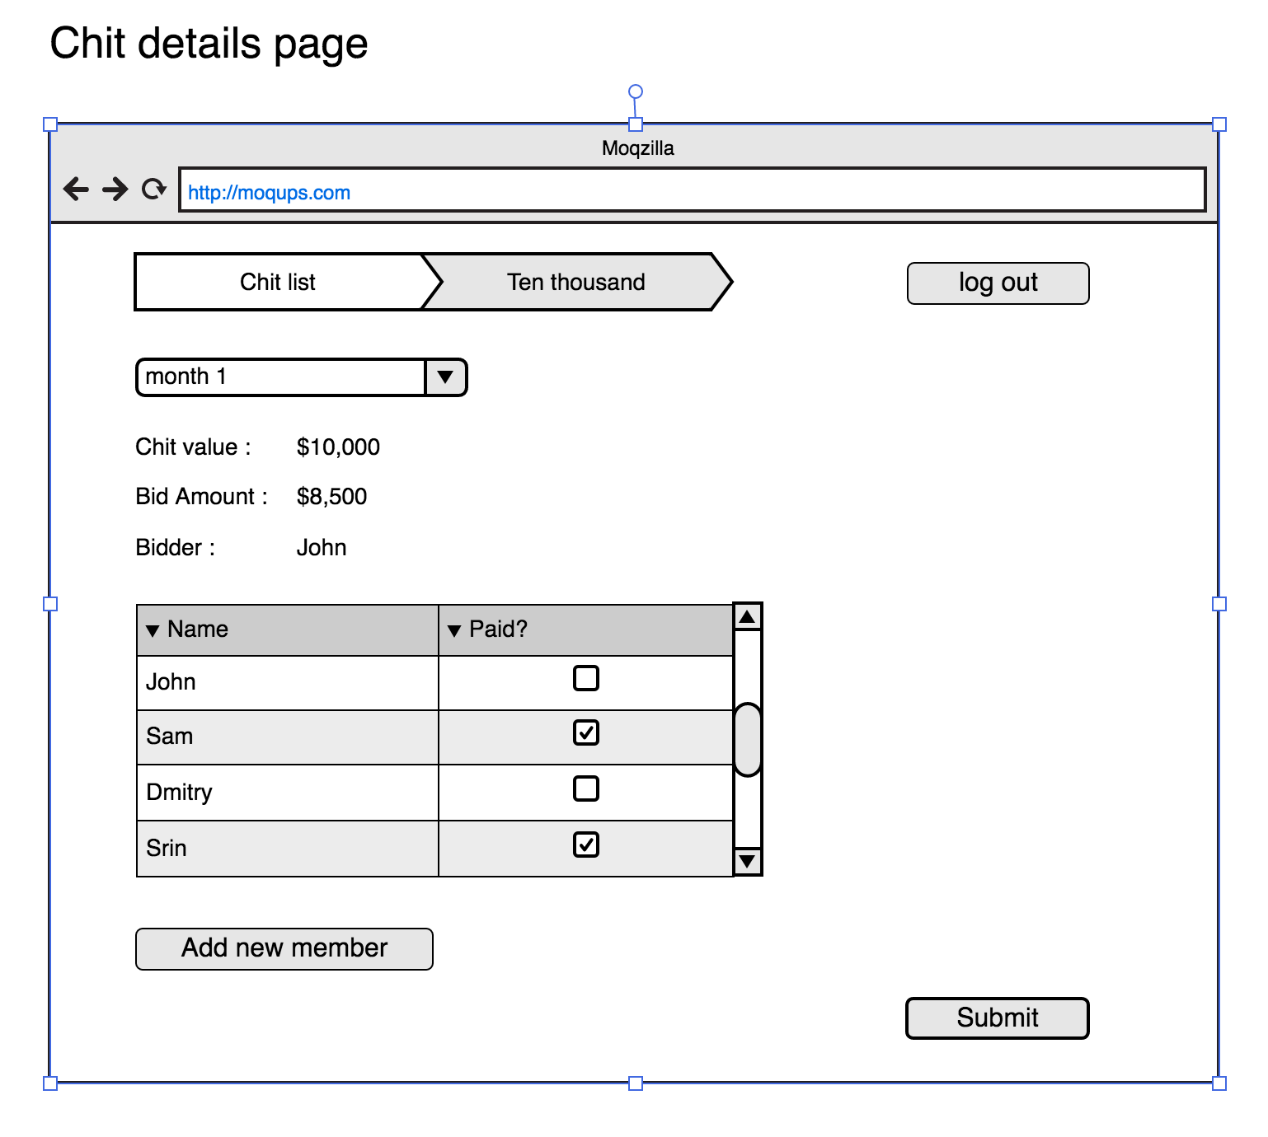

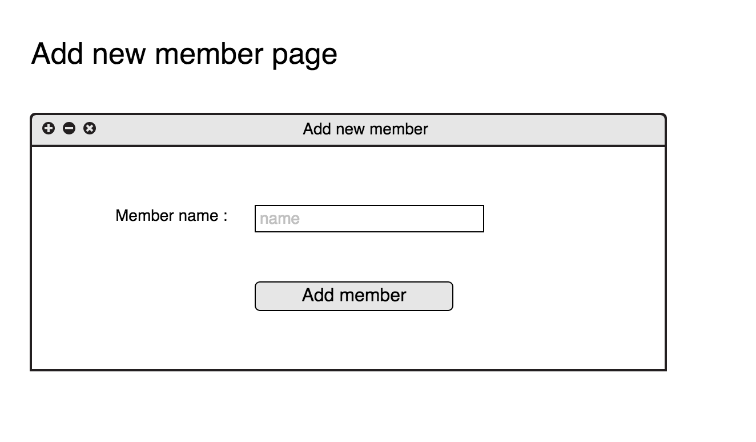

# 4. References

Similar applications

* <https://itunes.apple.com/us/app/surabhi-chits-iphone-version/id1002380654?mt=8> (Surabhi Chits iPhone Version)
* https://play.google.com/store/apps/details?id=com.trachit (TraChit:Tracker for Chit Fund)
* https://play.google.com/store/apps/details?id=com.bagdais.cic (Chits Calculator)
* https://play.google.com/store/apps/details?id=com.sanks.easycalc 7(This app helps the members in a chit/chitty/kuries to calculate the monthly payable amount at the particular date of chit amount collection.)
* https://play.google.com/store/apps/details?id=net.venussolutions.chitintcalc (Chits Interest Calculator) This tiny app will helps to fix your bid amount, when you participate the Chit bids conducted by non banking private finances

Additional References

* http://www.aiacf.com/node/3109 - All Inida Association of Chit Funds (AIACF) web site detailing the operation of chit funds.
* https://en.wikipedia.org/wiki/Chit_fund - Wikipedia detailing the chit fund savings scheme